Part 1 — Hands-On Practice (Approx. 70 min)

A. Initialize and Configure (10 min)

Create a folder named day1_day2_practice.
Initialize Git and check for the .git folder.
Configure username + email (locally).
git init

git config user.name "Your Name"

git config user.email "your@email.com"

git config --list –local

OutPut :

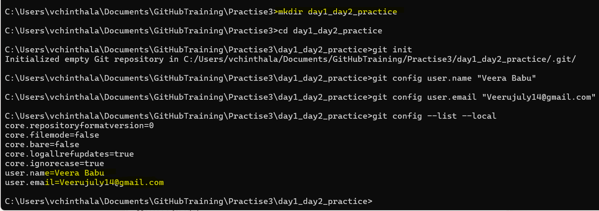

File Lifecycle
Create three files:
intro.txt setup.txt notes.txt
Add some text to each.
Output:
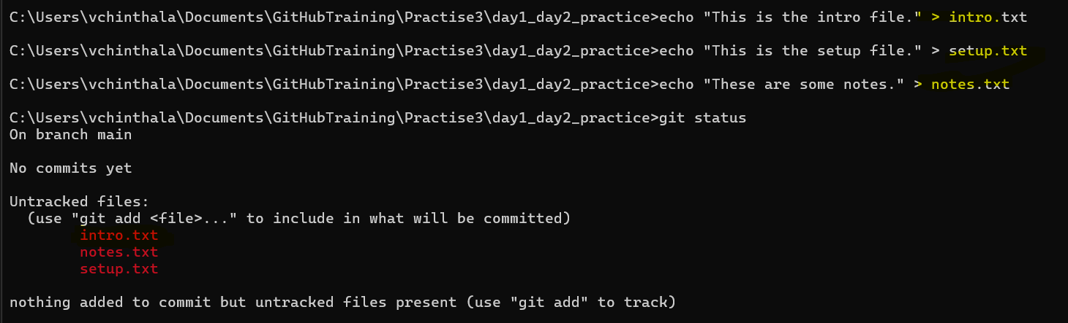

Stage only intro.txt and setup.txt.
git add intro.txt setup.txt

git status
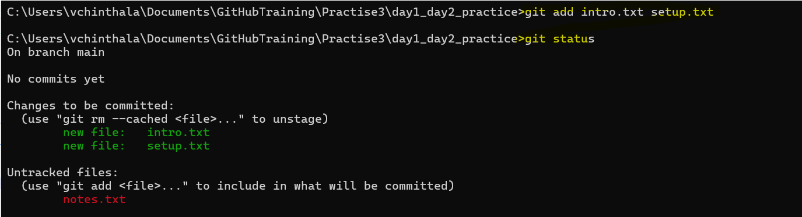

Edit intro.txt again without re-adding.
Compare results of:
git diff
OutPut :
Comment : It is showing unstaged changes also
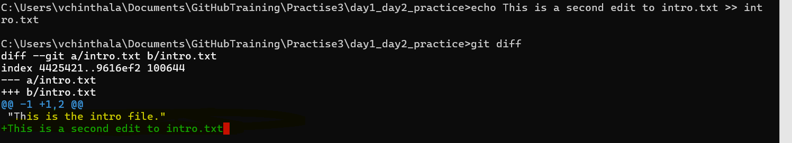

git diff –staged
OutPut :
Comment : This shows the staged snapshot

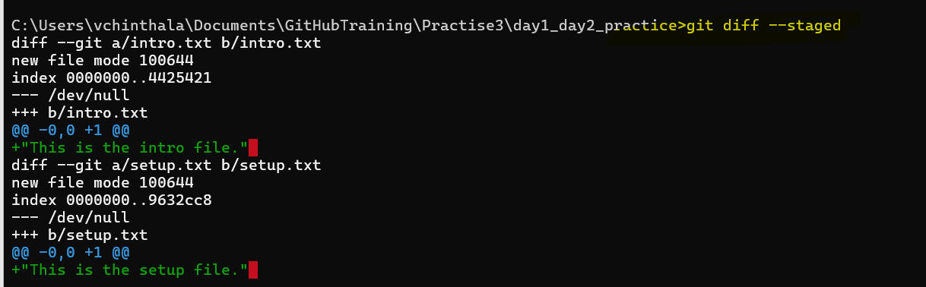

Commit staged files:
git commit -m "First commit - intro and setup"

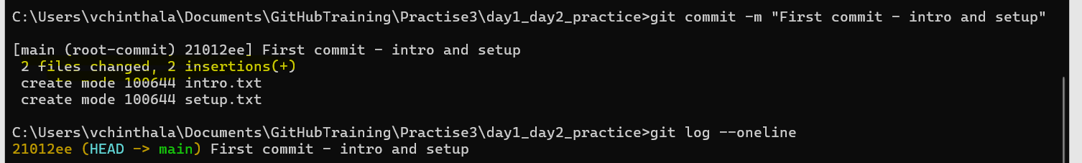

Deliverable → In 2–3 sentences, explain why the second edit to intro.txt didn’t go into the commit.

Answer :
The second edit to intro.txt didn’t go into the commit because Git only includes changes that have been staged using git add, If you want to commit the second edited changes need to stage those changes

displays a simple view of your commit history, showing:
The commit message and ID

git show HEAD
Displays the recent commit in detail like Author name, Date and Time
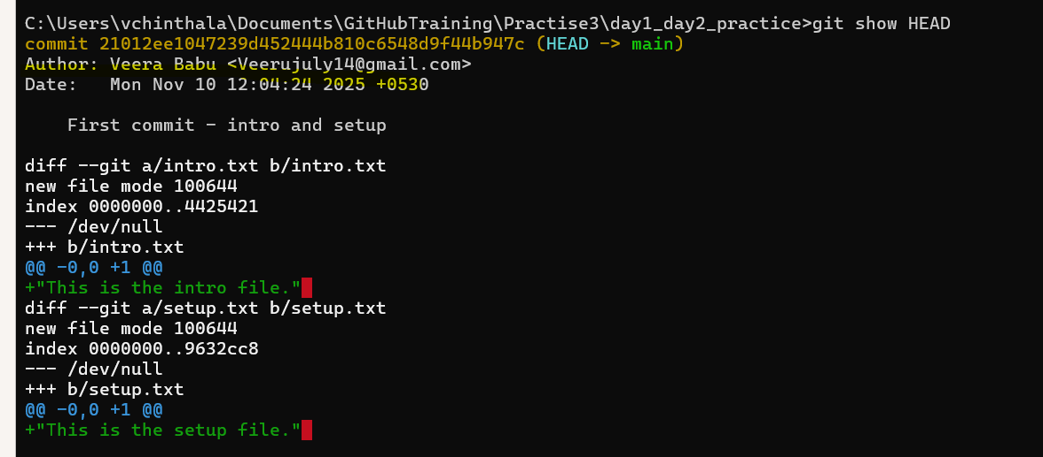
displays the contents of the latest commit object in a readable format. It shows:
- The tree hash (points to the directory structure)
- The author and committer info (name, email, timestamp)
- The commit message

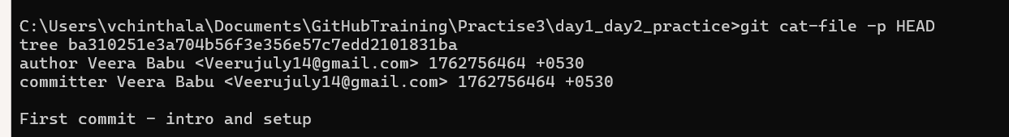

Part_2 Conceptual Quiz

What happens inside Git when you run git add file.txt?
Git takes the current version of file.txt and adds it to the staging area. This means Git is preparing that version to be included in the next commit. It doesn’t save the file yet — just marks it for saving.
Example :
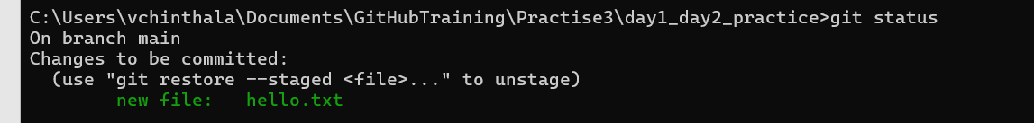
Why do we say a commit is a snapshot, not a diff?
A commit saves the full state of all staged files at that moment, not just the changes. Git stores this as a snapshot of your project, making it easy to go back to any version. It’s more reliable than just saving differences.
What is stored inside the .git folder?
The .git folder holds all the data Git needs to track your project. It stores commits, branches, configuration, and the full history of your files. This is what makes your folder a Git repository.
What does HEAD point to, and how is it updated?
HEAD points to the latest commit in your current branch. When you make a new commit, HEAD moves forward to that new commit. It helps Git know where you are in the project history.
What’s the difference between the Working Directory and the Staging Area?
The Working Directory is where you edits files. The Staging Area is where you prepare files for commit. Changes in the working directory aren’t saved until you stage and commit them.
In below first one is example of Working Directory and second is Staging Area
What happens if you change a file after staging it?
The staged version stays the same until you run git add again. Git will only commit the version that was staged, not the new changes. You can see the difference using git diff.
Example : Second one in below is not staged but changed
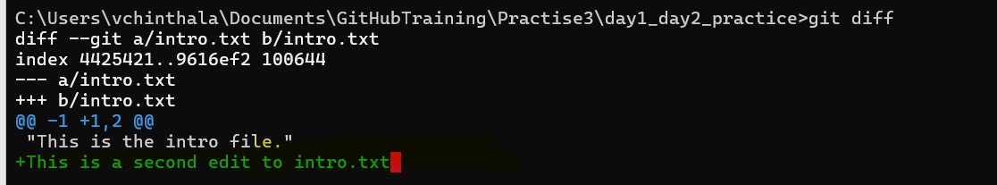
Why doesn’t Git store whole files for every commit?
Git uses smart storage to save space. It stores each unique file version once and reuses it across commits. This makes Git fast and efficient, even for large projects.
What is version control, and how does Git make it easier?
Version control lets you track changes to files over time. Git makes it easy to save versions, undo mistakes, and work with others. You can go back to any point in your project history.
What are tracked vs untracked files?
Tracked files are files Git knows about and is managing. Untracked files are new or ignored files that haven’t been added yet. You can start tracking them with git add.

Write the complete flow of commands from creating a repo to committing your first file.
Flow :
git init
echo "Hello Git" > file.txt
git add file.txt
git commit -m "First commit"

Used in system:

